User Manual

Recovery Go

Software Development Project
Fall 2025

Developer:
Jesse Rocha-salazar

The authors acknowledge the guidance of Dr. Rahaf Barakat. This project was undertaken within the Software Development Capstone at Georgia Gwinnett College (Fall 2025).

11/12/2025
TABLE OF CONTENTS

Introduction 2
System Requirements 5
Installation Instructions 7
Feature-by-Feature Guide 9
Sign up/in Page 9
Patient 12
Dash Board 12
Progress 14
Plans 15
Manual Bilder 17
Doctor 20
Dashboard 20
Patients 22
Plans 24
Create 27
Settings 30
ABOUT PAGE Error! Bookmark not defined.
SIGN UP PAGE Error! Bookmark not defined.
SIGN IN PAGE Error! Bookmark not defined.
MAIN LAYOUT: Error! Bookmark not defined.
USER DASHBOARD: Error! Bookmark not defined.
1. “User Profile” section: Error! Bookmark not defined.
2. “Students” section: Error! Bookmark not defined.
3. “My Courses” section: Error! Bookmark not defined.
4. “Settings” section: Error! Bookmark not defined.
5) “SIGN-OUT ” BUTTON: Error! Bookmark not defined.
AN OVERVIEW OF THE COURSE COMPONENTS: Error! Bookmark not defined.
A) DELETING A COURSE: Error! Bookmark not defined.
C) ADDING A PRE-EXISTING STUDENT TO THE COURSE: Error! Bookmark not defined.
G) REMOVING A STUDENT FROM THE COURSE: Error! Bookmark not defined.
H) UPDATING THE ENROLLMENT STATUS OF A STUDENT: Error! Bookmark not defined.
J) ADDING A NEW SESSION TO THE COURSE: Error! Bookmark not defined.
K) SCANNING STUDENTS INTO A SESSION/ TAKING SESSION ATTENDANCE: Error! Bookmark not defined.
M) DELETING A SESSION: Error! Bookmark not defined.

Introduction

Brief description
RecoveryGo is a cross-platform (Android + Web) rehab companion that helps people follow safe, structured recovery routines. Patients can onboard with their profile (Athlete, Senior, General User), choose or build routines, and track progress. Clinicians get a lightweight portal to assign routines and review patient status. The app uses Firebase for authentication and data, and is designed with an accessible, mobile-first UI.
Purpose & intended audience
- Patients: anyone recovering from injury/surgery who needs clear, daily guidance.
- Clinicians (Doctors/Therapists): assign shareable routines, tailor plans to individuals, and streamline follow-ups.
- Caregivers/Coaches: view simple summaries to support adherence.
Key features overview
- Guided Onboarding: select user type (Athlete/Senior/General or Doctor/Therapist) to personalize the experience.
- Authentication: email/password and Google Sign-In (Firebase Auth).
- Patient Dashboard: “Today’s Progress” card, routine checklist, and quick actions.
- Plans:
  - AI Plans (planned): generate a tailored routine from user inputs (injury, goals, time), review, then save to Firestore.
  - Manual Builder (implemented): add/edit exercises with sets, reps/duration, rest, and tags; save as reusable routines.
  - Templates: starter plans (e.g., knee recovery, mobility) that can be customized.
- Progress Tracking: visual completion bar and daily breakdowns (patient side).
- Doctor Tools: patient list, recommended plans, “Assign Routine” flow, and notes.
- Settings & Accessibility: large text, high contrast, text-to-speech toggle (UI in place), notifications/privacy stubs.
- Data & Storage: Firestore documents for users and routines (createdAt/updatedAt, visibility, exercise arrays, summaries).
- Cross-platform Stack: Expo + React Native UI, Firebase (Auth/Firestore), designed for low friction on mobile.

System Requirements

Hardware
- Development machine: 8 GB RAM minimum (16 GB recommended), 10–20 GB free disk.
- CPU virtualization enabled for Android Emulator (Intel HAXM/Hyper-V/WHPX).
- Optional devices: recent Android phone or iPhone/iPad for on-device testing.
Operating Systems
- Development: Windows 10/11, macOS 12+ (Monterey or newer), or a recent Linux distro.
- iOS local builds require macOS with Xcode 15+.
- Android local builds: Android Studio (latest stable) with Android SDK/NDK; JDK 17.
Software Stack
- Node.js 18 LTS (recommended) or 20; npm or Yarn.
- Expo SDK ~54 (expo ~54.0.10), React Native 0.81.x, React 19.1.0.
- Key libs: firebase ^12.3.0, @react-navigation/*, react-native-reanimated ~4.1.0.
- Expo CLI via npx expo (no global install required).
- Git (for source control).
Browsers (Web Target)
- Latest Chrome (recommended), Edge, Firefox, or Safari for running the web build and DevTools.
Cloud Services and Env
- Firebase project (Auth, optional Storage/Firestore as configured in your console).
- Required env vars in .env (client-exposed via Expo):
  - EXPO_PUBLIC_FIREBASE_API_KEY
  - EXPO_PUBLIC_FIREBASE_AUTH_DOMAIN
  - EXPO_PUBLIC_FIREBASE_PROJECT_ID
  - EXPO_PUBLIC_FIREBASE_STORAGE_BUCKET
  - EXPO_PUBLIC_FIREBASE_MESSAGING_SENDER_ID
  - EXPO_PUBLIC_FIREBASE_APP_ID
  - EXPO_PUBLIC_OPENAI_API_KEY (for AI plan features)
- Note: EXPO_PUBLIC_* values are embedded in the client bundle; restrict usage in Firebase console as needed.

Installation Instructions

Go to https://github.com/Jesserochasalazar/recoveryGO
- Prerequisites
  - Node.js 18 LTS (recommended) or 20, npm or Yarn.
  - Expo SDK ~54 (use npx expo), React Native 0.81.x, React 19.1.0.
  - Git (for source control).
  - Android: Android Studio (SDK + emulator) or a physical device with Expo Go.
- Clone Repo
- git clone <repo-url> RecoveryGo
- cd RecoveryGo
- npm install
- Create a Firebase project & enable services
  - Go to Firebase Console → Create Project .
  - In Build → Authentication → Sign-in method:
    - Enable Email/Password.
    - Enable Google.
  - In Build → Firestore Database:
    - Create database in test mode (for local dev), or set rules (see step 7).
  - In Project settings → General → Your apps:
    - Add a Web app; copy the config values (apiKey, authDomain, etc).
  - In Authentication → Settings → Authorized domains, make sure these exist for dev:
    - localhost
    - recoverygo-fce10.firebaseapp.com (your project domain)
    - recoverygo-fce10.web.app
    - auth.expo.io (needed for Expo Go during development on Android/iOS)
  - For Android Google Sign-in with Expo, you’ll later create an OAuth Client (Android) in Google Cloud and supply SHA-1/256 if you move to a production build. For Expo Go, keeping auth.expo.io on the authorized domain list is typically enough for dev.
- Add environment variables
  - Create a .env at the project root
  - Use the information in the ‘.env.example’
  - Fill in with your information
- RUN
  - npx expo start

Feature-by-Feature Guide

Sign up/in Page

This is where you log into your Existing account. This page will have you:
- Step 1: Enter your email and password to log in.
  - Then Click the “Sign In” button.
- Step 2: Complete sign-up process if not completed.
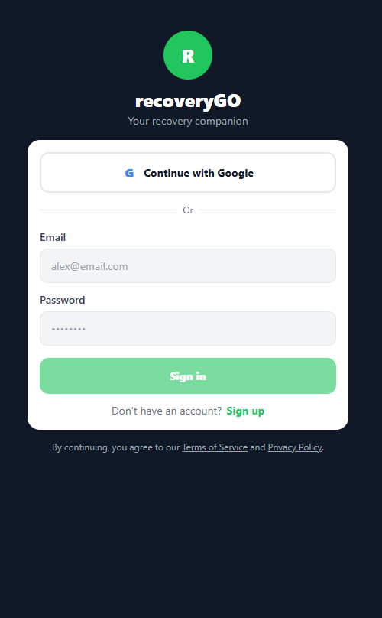
This is where you create an account within the app. This page will have you:
- Optional signup with google account
- Step 1: Enter your email address.
- Step 2: Create your password.
- Step 3: Complete sign-up process.
  - Click the “Create Account” button to successfully create an account.
  - This will take you to the onboarding page
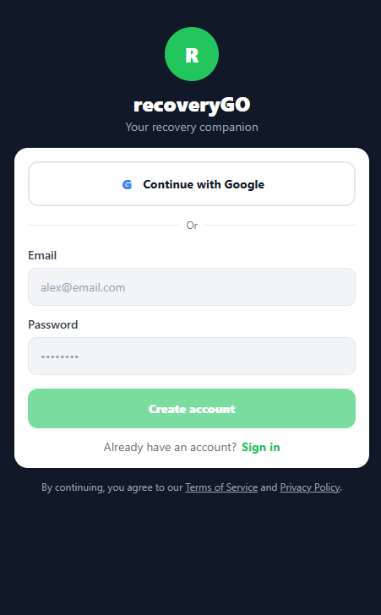

OnBoarding

- Open the app & sign in
  - New users are automatically routed to Onboarding.
  - Returning users who haven’t completed onboarding yet will also be routed to Onboarding.
- Enter your basic info
  - Type your First name, Last name, Gender, and Age.
- Choose your account type
  - Athlete / Senior / General User → You’ll use the Patient experience (Dashboard, Progress, Plans, Settings).
  - Doctor/Therapist → You’ll get the Doctor tools (Dashboard, Patients, Create Routine, Settings).
- Submit
  - Tap Continue (or Save/Finish).
  - The app saves your profile and marks you as onboarded.
- Automatic redirect
  - Patient types → /patient/dashboard
  - Doctor/Therapist → /doctor/dashboard

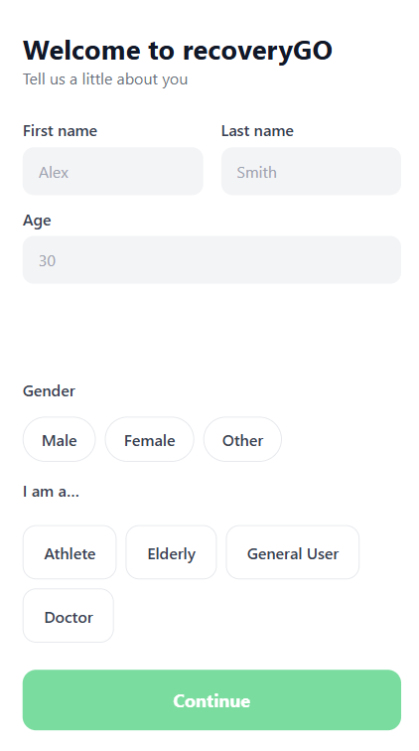

Patient

Dash Board

- Open the app and sign in
  - If you’re a patient (Athlete/Senior/General User), you’ll land on Patient Dashboard automatically.
- Review Today’s Progress
  - The green progress card shows how many items you’ve completed today.
  - Tap the card to open the Progress screen for more details (history, trends).
- Pick or manage a plan
  - In My Plans, tap Start on a plan to jump into its flow, or tap New to create or browse plans.
- Complete today’s routine
  - Scroll to Today’s Routine.
  - Tap Start on an exercise to view or log it. Completed items show a checkmark and “Complete” badge.
- Open Settings
  - Tap the gear icon in the header to edit your profile, accessibility preferences, notifications, e

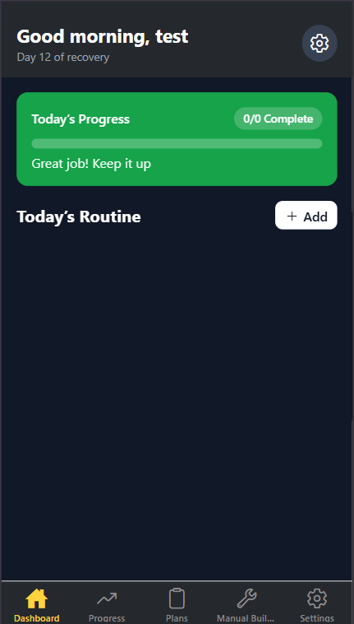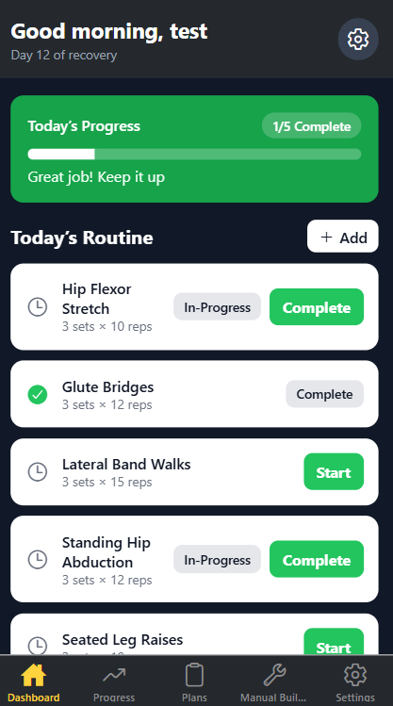
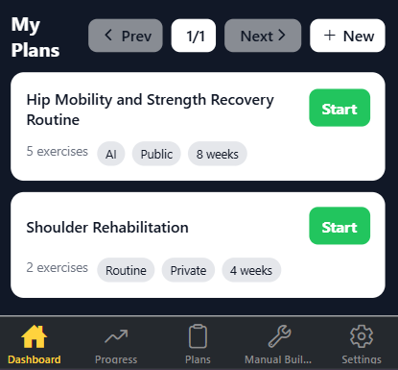

Progress

- Shows your recovery over time—daily completions, streaks, and trends—so you can see what you did, what’s next, and how you’re improving.

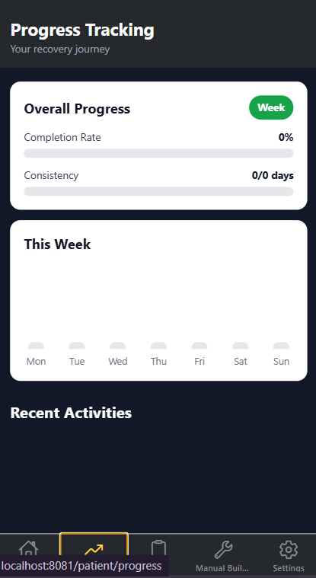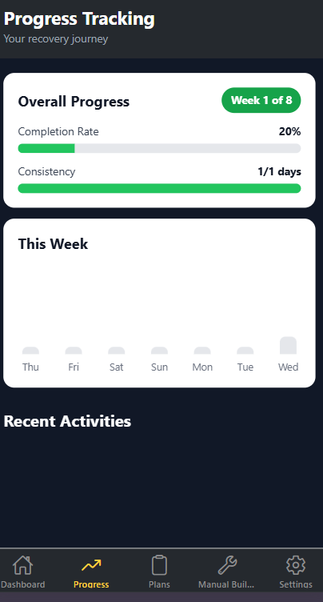

Plans

- Open Plans
From the Dashboard, go to Plans.
- Tap “Create Custom Plan”
- Fill out the form
  - Injury / focus area (e.g., “shoulder rehab” or “post-op knee”)
  - Goals (e.g., “reduce pain”, “increase ROM”, “build strength”)
  - Duration (weeks)
  - # of exercises (e.g., 6–12)
  - Difficulty (Beginner / Intermediate / Advanced)
  - Visibility (Private / Public)
- Generate & Save
Hit “Generate & Save” (button stays disabled until form is valid).
- What the app does (automatic)
  - Calls OpenAI with your inputs → generateRoutineFromAIClient).
  - Normalizes the AI result → normalizeForSave
  - Saves to Firestore → createGeneratedPlan
  - Refreshes your Saved Plans list.
- Use or Edit (Work in Progress)
  - Tap Use This Plan to go back to Dashboard
  - Tap Edit to open the manual builder and tweak details
→ /patient/manual-builder (see app/patient/manual-builder.tsx).

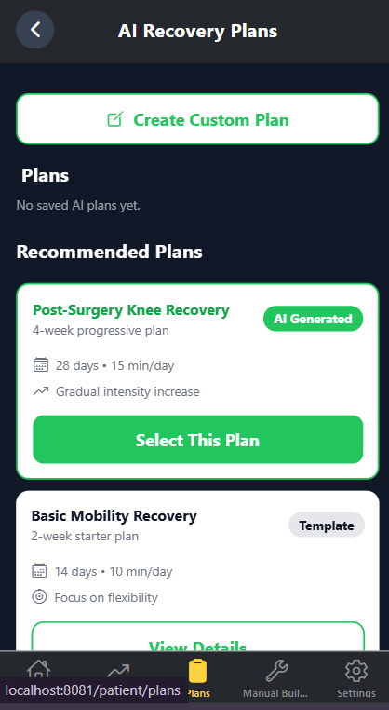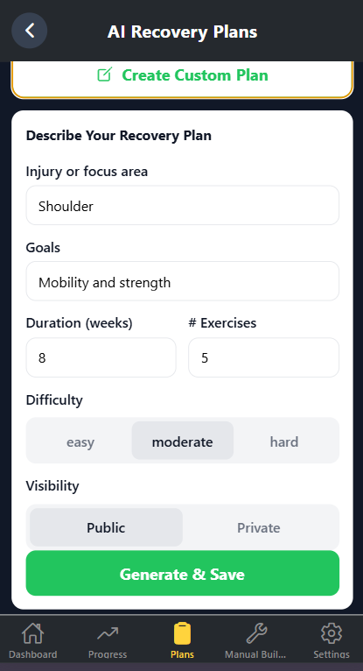

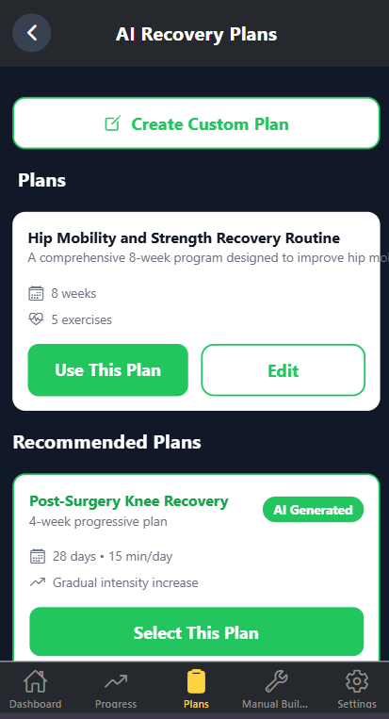

Manual Builder

- Fill Routine Details
  - Title & Description
    - At the top of the form
  - Duration
    - Pick via chips: 2 / 4 / 6 / 8 weeks (~line 9, ~line 167).
  - Visibility
    - Set to Private or Public (~lines 200–208).
- Manage Exercises
- See the count
  - The header shows Exercises (…count…)
- Add Manually
  - Tap Add Exercise, fill name / sets / reps / rest / duration (optional) / category / bodyPart, then Add
- Edit an Exercise
  - Tap Edit, update any field you need:
    - name , sets/reps , rest , duration , category , bodyPart
- Delete an Exercise
  - Tap Delete
- Save the Routine
- Sign-in required
  - If not signed in, you’ll be prompted
- Save
  - Tap the save icon in the header to persist to Firestore via upsertRoutine
- What gets saved
  - name, description, duration, visibility, exercises, plus a summary (totals)
- Edit an Existing Routine
  - Open the builder with an id:
/patient/manual-builder?id=<routineId>
The builder loads the routine for editing

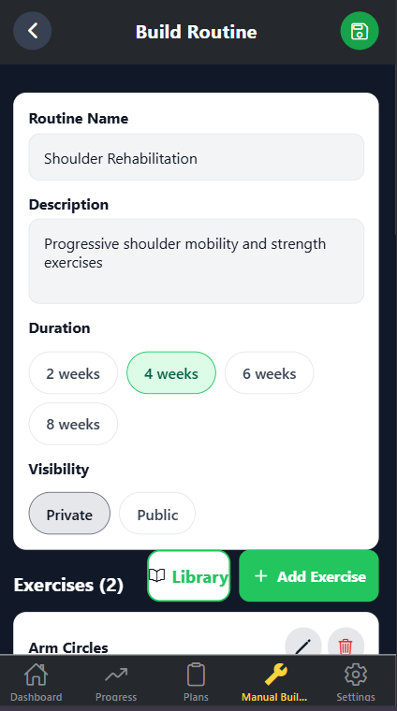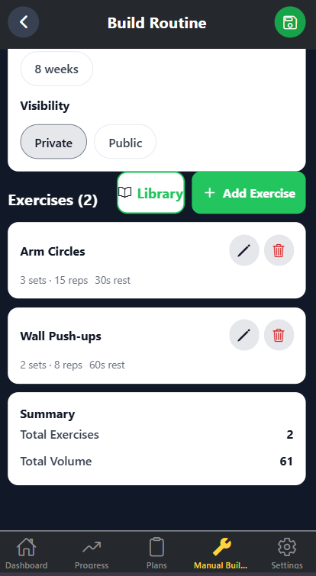
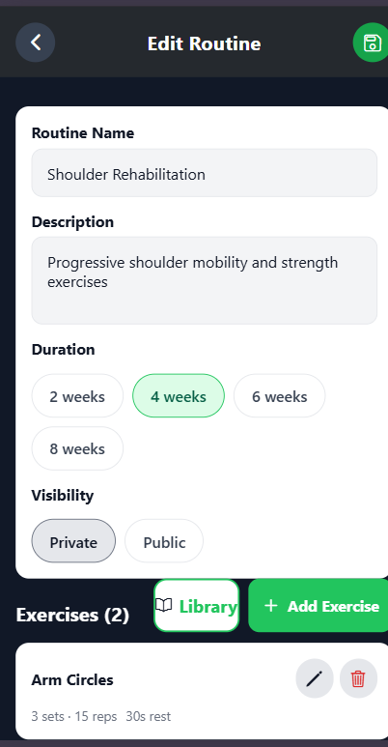

Doctor

Dashboard

Step 1 — Open the Screen
- Navigate to /doctor/dashboard
Step 2 — Confirm Your Name
- Name loads from AsyncStorage profile via getJSON('profile')
  - Loader: app/doctor/dashboard.tsx
  - Storage util: src/utils/storage.ts
- Display shows “Dr. <FirstName>” when userType === 'doctor'
Step 3 — Settings
- Tap the gear icon to open Settings
Step 4 — Manage Patients
- Tap Manage Patients to go to /doctor/patients
- Patients screen supports search and actions like Assign Routine / View Report
Step 5 — Create New Routine
- Tap Create New Routine to open the builder at /doctor/create
- The builder uses your doctor-oriented routine screen (app/doctor/create.tsx, line 1).
Step 6 — Review Quick Stats
- Active Patients and Plans Pending are demo counters for now

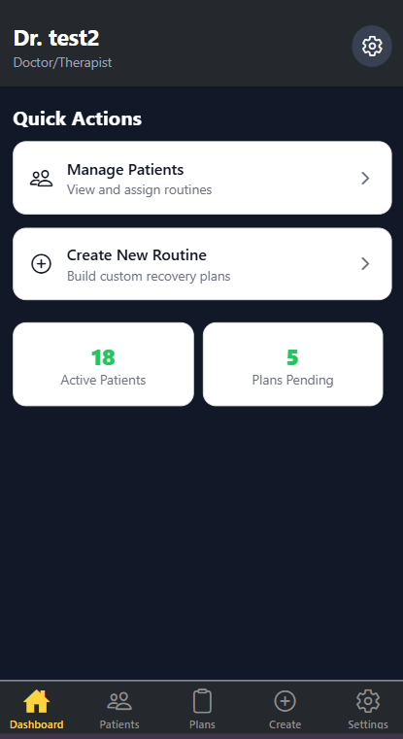

Patients

Step 1 — Open the Screen
- Navigate to /doctor/patients from Quick Actions on the Doctor Dashboard or directly.
Step 2 — Header / Back
- Use the Back button in the header to return to the previous screen
Step 3 — Search Patients
- Type in the search box to filter by name,
Step 4 — Review the List
- Each patient card shows:
  - Avatar initials, name, condition
  - Status badge (Active/New/Completed)
  - Progress %
Step 5 — Take Actions
- Completed patients: tap “View Report” → /doctor/patient/<id>/report.
- Active/New patients: tap “Assign Routine” → /doctor/patient/<id>/assign.
Step 6 — Empty State
- If your search returns no matches, you’ll see an informative empty message.

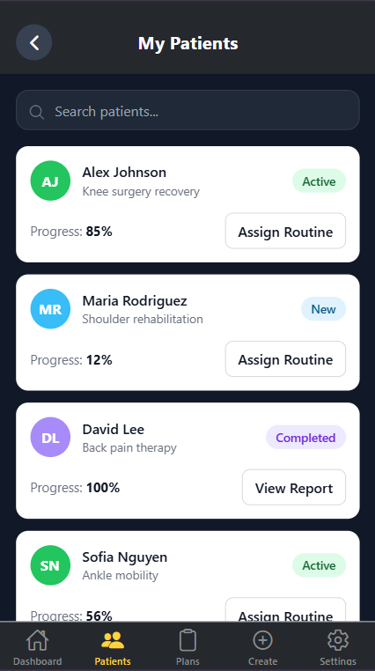

Plans

- Open Plans
From the Dashboard, go to Plans.
- Tap “Create Custom Plan”
- Fill out the form
  - Injury / focus area (e.g., “shoulder rehab” or “post-op knee”)
  - Goals (e.g., “reduce pain”, “increase ROM”, “build strength”)
  - Duration (weeks)
  - # of exercises (e.g., 6–12)
  - Difficulty (Beginner / Intermediate / Advanced)
  - Visibility (Private / Public)
- Generate & Save
Hit “Generate & Save” (button stays disabled until form is valid).
- What the app does (automatic)
  - Calls OpenAI with your inputs → generateRoutineFromAIClient).
  - Normalizes the AI result → normalizeForSave
  - Saves to Firestore → createGeneratedPlan
  - Refreshes your Saved Plans list.
- Use or Edit (Work in Progress)
  - Tap Use This Plan to go back to Dashboard
  - Tap Edit to open the manual builder and tweak details




Create

- Fill Routine Details
  - Title & Description
    - At the top of the form
  - Duration
    - Pick via chips: 2 / 4 / 6 / 8 weeks
  - Visibility
    - Set to Private or Public
- Manage Exercises
  - See the count
    - The header shows Exercises (…count…)
  - Add Manually
    - Tap Add Exercise, fill name / sets / reps / rest / duration (optional) / category / bodyPart, then Add
  - Edit an Exercise
    - Tap Edit, update any field you need: name , sets/reps , rest , duration , category , bodyPart
  - Delete an Exercise
    - Tap Delete
- Save the Routine
  - Sign-in required
    - If not signed in, you’ll be prompted
  - Save
    - Tap the save icon in the header to persist to Firestore via upsertRoutine
  - What gets saved
    - name, description, duration, visibility, exercises, plus a summary (totals)
- Edit an Existing Routine
  - Open the builder with an id:
The builder loads the routine for editing




Settings

- This is still in work in progress element, completed planned UI.

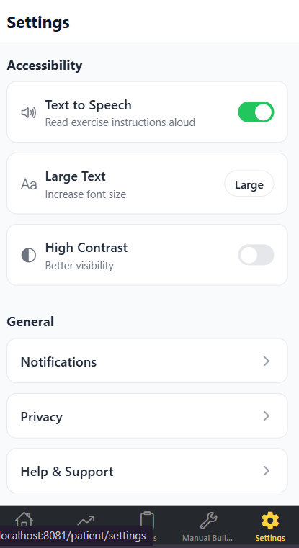

AI Features

AI Plan Generation — How to Use, Limits, and Tips
Setup
- Add your key to .env and restart Expo:
  - EXPO_PUBLIC_OPENAI_API_KEY=sk-...
- (Optional) Fallback via expo.extra.OPENAI_API_KEY in app.config.ts.
- Ensure Firebase envs are set so Firestore saves work (Auth + Firestore enabled).
- Model used: gpt-4o-mini. Output requested as JSON.
- Create an account using OpenAI API keys.
  - Create account and setup keys for project

How to Use
- Open Plans
  - Patient: /patient/plans
  - Doctor: /doctor/plans
- Reveal AI Form
Toggle Create Custom Plan to show inputs (injury/focus, goals, duration weeks, # of exercises, difficulty, visibility).
- Generate & Save
Tap Generate & Save. The app:
  - Calls OpenAI with your inputs.
  - Validates/normalizes the JSON.
  - Saves the plan into Firestore (name, description, duration, visibility, exercises, summary totals).
- Use or Edit
  - Use This Plan to return to your dashboard.
  - Edit to tweak in the Manual Builder (/patient/manual-builder).
Limitations
- Client-exposed key: Anyone can inspect a web build; use rate limits, domain restrictions, and rotate keys. Prefer a server proxy for production.
- Cost & rate limits: API usage is billed and can throttle; errors are surfaced to the user.
- Clinical accuracy: AI output is not medical advice; a clinician should review before assigning.
- JSON fidelity: The model is asked for JSON, but malformed responses can still occur—code guards with try/catch and fallbacks.

Tips for Accurate Results
- Be specific: Include injury type, recovery stage (e.g., “post-op week 2”), pain level, equipment access, and daily time budget.
- Set clear goals: Mobility vs. strength vs. stability; target body parts.
- Right-size scope: Reasonable durationWeeks and numExercises produce better plans.
- Difficulty: Start at easy/moderate; iterate upward based on progress.
- Iterate & edit: Generate first, then fine-tune sets/reps/rest/categories in the Manual Builder.

Troubleshooting
- “Missing OpenAI API key” → Add EXPO_PUBLIC_OPENAI_API_KEY and restart Expo.
- Generation failed → Check network, verify key, confirm model name, inspect console logs.
- Plan saved but not reflected in progress → Ensure the “Use This Plan” action is wired to whichever session/progress document your dashboard reads.

Future Developer Guidance

Technology stack & versions
- Expo SDK ~54, React Native 0.81.x, React 19.1
- Routing: expo-router
- Firebase: firebase ^12.3.0 (Auth, Firestore)
- Persistence (native): @react-native-async-storage/async-storage
- Auth (native Google): expo-auth-session, expo-linking (recommended)
- Optional AI: OpenAI API (gpt-4o-mini) via a server proxy (recommended) or client key (dev only)

Setting up a dev environment
- Prereqs
  - Node 18 LTS (or 20), Git, Android Studio (for emulator), JDK 17.
  - Optional: iOS builds require Xcode on macOS.
- Install
  - npm i
  - npx expo install @react-native-async-storage/async-storage
  - npx expo install expo-auth-session expo-linking
- Environment
  - Create .env:
    - EXPO_PUBLIC_FIREBASE_API_KEY=...
    - EXPO_PUBLIC_FIREBASE_AUTH_DOMAIN=...
    - EXPO_PUBLIC_FIREBASE_PROJECT_ID=...
    - EXPO_PUBLIC_FIREBASE_STORAGE_BUCKET=...
    - EXPO_PUBLIC_FIREBASE_MESSAGING_SENDER_ID=...
    - EXPO_PUBLIC_FIREBASE_APP_ID=...
    - # Optional (dev only):
    - EXPO_PUBLIC_OPENAI_API_KEY=...
  - Ensure Firebase Authentication (Email/Password + Google) and Firestore are enabled.
- Auth persistence (native)
  - Use initializeAuth(app, { persistence: getReactNativePersistence(AsyncStorage) }) and export that auth.
- Run
  - npx expo start

Known issues / technical debt
- Settings incomplete (UI only)
  - Action handlers not wired; keep all UI in SettingsContents.tsx and export from app/*/settings.tsx.
- Architecture needs cleanup
  - Duplicate UI across screens; start extracting shared components:
    - components/ui/Card.tsx, components/ui/Header.tsx, components/ui/Badge.tsx
    - components/plans/PlanCard.tsx
    - components/routines/ExerciseRow.tsx
    - components/patients/PatientListItem.tsx
- AI plan generation (in progress)
  - Works on web; move to a server proxy for production to hide the key.
  - Validate JSON strictly; keep a fallback template.
- Async update bug (plans not refreshing)
  - Symptom: must log out/in to see new plans.
Fix: replace one-off reads with Firestore listeners:
  - Also update dashboard to read from a listener (not static state).
- Google sign-in on Android (Expo Go)
  - signInWithPopup does not work on native. Use expo-auth-session to obtain tokens, then:
  - Configure a custom scheme in app.json and add Expo’s proxy redirect URI in Google Console.
- Firestore rules currently permissive / expiring
  - Replace the temporary rule with per-resource, authenticated checks (see “Security rules” below).
- Web COOP warnings with popup auth
  - Harmless noise from window.close in popup flow. Consider signInWithRedirect on web to reduce console spam.

Suggestions for future improvements

Architecture
- Introduce hooks: src/hooks/useAuth, useUserProfile, usePlans, useTodayRoutine.
- Consolidate Firestore operations in src/services/firestore.ts with typed converters.
- Add role-based navigation guards to route users to /patient/* or /doctor/* after login.
AI
- Move OpenAI calls to Cloud Functions or a minimal server; accept only safe, structured inputs.
- Add “regenerate step” and comparison view (diff of old vs new plan).
UX
- Add Optimistic UI for creating/editing routines.
- Add pull-to-refresh on lists and a global loading/toast system.
- Make settings actionable: notifications, text-to-speech, contrast, font size.
Data
- Store doctor-to-patient assignments under patients/{patientId}/assignments/{assignmentId}.
- Add summary Cloud Function to compute totals on write (reduces client calc bugs).
- Enable Firestore offline persistence for better native experience.
DevOps
- Split staging/prod Firebase projects; parametrize via Expo eas.json and app.config.ts.
- Add tests (Jest + @testing-library/react-native) and minimal E2E (Detox for native; Playwright for web).
- Add CI (lint, typecheck, test) and EAS Build/Submit pipelines.

Support & Contact Information

Email: jesserocha@gmail.com
Version of Manual : 1.1

